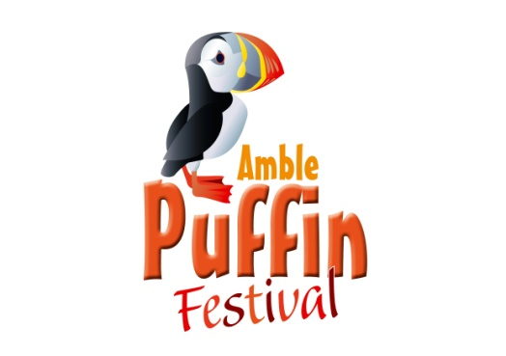  2024 | Saturday 25 May  &  Sunday 26 May  10.30am – 3.30pm

In and around the Town Square Amble NE65 0DQ

This is your opportunity to join in the 2024 Puffin Festival.
During the event there will be community activities, craft stalls, food, games and entertainment… and Puffins !

Space (approx. 3.5 x 3.5m) available @ £35 per day
We recommend you book early as space will be allocated on a ‘first come’ basis
Supply your own gazebo/table/chair etc.

Please note that stalls must be dismantled overnight as no security is available.
Access available from 9.00am: No entry after 10 am; No clear away before 3.30p.m.
All packaging etc. to be removed

Please see separate sheet for full terms and conditions.

STALL HOLDER BOOKING FORM
NAME (Please PRINT):
ADDRESS:
TELEPHONE:
EMAIL:
TYPE OF BUSINESS:

I wish to attend on Saturday (on receipt of full payment)
I wish to attend on Sunday (on receipt of full payment)

Please enclose your cheque, for the correct amount, payable to Amble Events Committee.
Bank details: Amble Events Committee, Acc no: 42940025 Sort code: 09-01-29

In the event that you cancel your booking, no refund can be given.

If you have any queries at all please contact on 01665 712929 or by email julia@ambledevelopmenttrust.org.uk before completing your form.
Thank you!

Please return this form to
Amble Events Committee, Fourways 2, 6 Dilston Terrace, Amble. NE65 0DT
Full T&C as per separate, enclosed, sheet.
By returning your booking form you are deemed to have read and agreed to these.

Follow us on Facebook AmblePuffinFestival and Twitter @AmblePuffinFest

